4A - Probability – Lesson 03
Relative Frequency – Probability Validity.

Name: _________________

- A coin is tossed. What is the theoretical probability of a head?
n(E)
n(S)
P(E) = =

- Toss a coin 50 times to see if experimental probability equals theoretical probability. Expectation of an H equals 25.

 | Tally | Frequency
H
T

Was the theoretical probability close to the experimental probability? Y/N

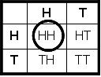
- Two coins are tossed. What is the theoretical probability of HH?
n(E)
n(S)
n(S) = 4 n(E) = P(E) = =

- Toss two coins 48 times to see if experimental probability of HH equals theoretical probability of HH. Expectation of HH equals 12.

 | Tally | Frequency
HH
TT
HT

Was the theoretical probability close to the experimental probability? Y/N

- A single dice is tossed. What is the theoretical probability of a six?
n(E)
n(S)
P(E) = =

- Toss a die 48 times to see if experimental probability equals theoretical probability. Expectation of a six equals 12.

 | Tally | Frequency
1
2
3
4
5
6

Was the theoretical probability close to the experimental probability? Y/N

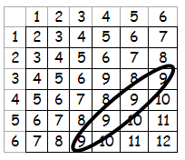
- What is the theoretical probability of throwing two die and their sum being 9.

n(S) = 36, n(E) =
n(E)
n(S)
P(E) = =

- Toss a die 54 times. Expectation of a nine equals six.

 | Tally | Frequency
2
3
4
5
6
7
8
9
10
11
12

Was the theoretical probability close to the experimental probability? Y/N

